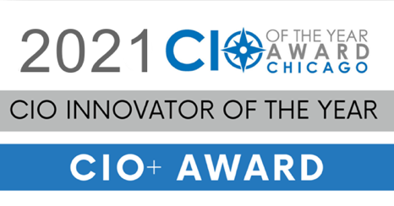

Please complete and return this application via email to ciooftheyearaward@sim-chicago.org by May 31, 2021

Congratulations on being nominated for the CIO of the Year Award.
Since 1995, the Society of Information Management (SIM) Chicago Chapter, together with The Executives’ Club of Chicago and the AITP Chicago Chapter have recognized technology leaders with the premier CIO of the Year Award. Selection considers leadership in driving business value, technological innovation, business partnerships and creating best-in-class workplaces for IT professionals. Finalists will be interviewed and the winner will be announced at SIM Gala on October 14, 2021.
CIO Nominee:
Name:

Company:
Title:

Email: Phone Number:
C-Level Reference at Company:
Name:

Company:
Title:

Email: Phone Number:
Application Instructions:

Applicants will be judged on the criteria below.
Please submit responses to the questions below in a single Word document to ciooftheyearaward@sim-chicago.org or use this document as a template. Initial scoring will be based solely on the information submitted within this application. Be sure to demonstrate value in your responses.
Include a brief description of the business, a resume or CV, and provide a headshot of the applicant for public release.
CIO of the Year Award Criteria:
- LEADERSHIP ROLE IN THE ORGANIZATION: What is the scope of your role in the organization, specifically how strategic is it (does it inform and impact the business) and how much breadth does it involve (roles beyond typical IT, CEO / board relationship, etc.)? How much does technology strategy align with and drive business strategy? What is your relationship with the Executive Team and the Board of Directors?

- VALUE CREATION: What value creation have you generated, including new revenue streams, improvements in customer service, and strategic/impactful cost savings/redeployment of capital? Describe how and when IT engages with strategic business initiatives.

- VALUE PROTECTION: How have you protected the value of your organization, specifically related to security, compliance and risk management?

- TEAM DEVELOPMENT: How have you evolved your team by attracting, retaining, and developing strong talent as well as improving process, implementing organizational change, and developing strategic partnerships? How have you helped your team members grow in their leadership abilities through mentoring or other approaches?

- BUILDING RELATIONSHIPS: How have you partnered with your internal organizational peers such as marketing, operations, finance, etc. and what impact has this had on the organization?

- TECHNOLOGY LEADERSHIP: How have you leveraged technology (existing, new, and/or emerging) in unique, effective, and forward-thinking ways to increase value for your organization and what is your vision for continuing to evolve?

- COMMUNITY INVOLVEMENT: How do you and your IT organization support community and social initiatives that positively impact the community? How does your IT department support existing or new diversity, equity, and inclusion efforts within your company or the broader Chicago community? How engaged are you in supporting the technology profession and in building relationships with your colleagues?

